On-Prem LLM + MCP + Grafana Loki: LLM Security based on Log Observability

- Architecture Overview
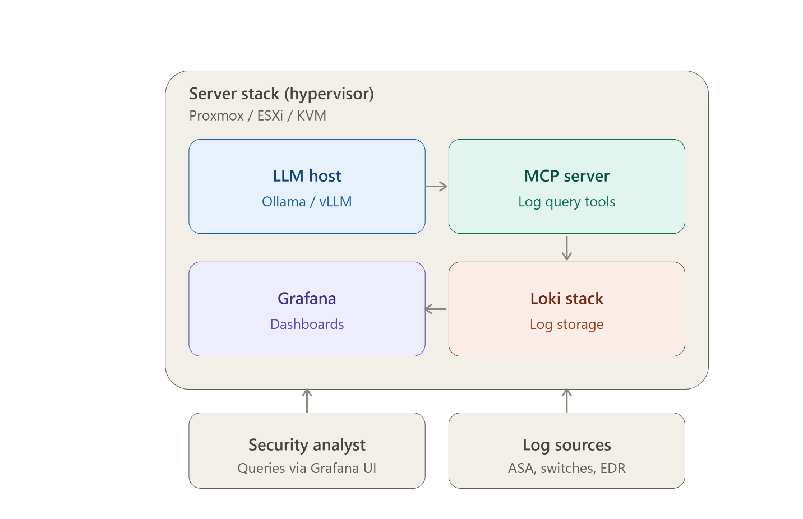
Each function runs in its own VM, which lets you isolate resource allocation, such as passing the GPU only to the LLM host. You can also set up separate RBAC and firewall rules for each VM, keeping the setup in line with Zero Trust segmentation. This approach is helpful if you later need to align with NIST 800-53 (AU, SC, SI control families) or CMMC log-review practices.

- Suggested VM Layout on Hypervisor

VM | Purpose of VM | vCPU | RAM | Disk | Notes
llm-host | Model Inference | 8-16 CPUs | 32-64 GB | 200 GB | GPU Passthrough (PCIe) if available
mcp-server | MCP Tool/Log Bridge | 2-4 CPUs | 8 GB | 50 GB | Lightweight, Mostly I/O
loki-stack | Log Aggregation/Storage | 4-8 CPUs | 16-32 GB | 500 GB | Disk Scales with Log Retention
grafana | Visualization | 2 CPUs | 4-8 GB | 20 GB | Can Be Merged with Loki

On Proxmox, GPU passthrough requires that IOMMU be enabled in the BIOS and that vfio-pci be loaded.
It must be attached to the card when the virtual machine is created; on ESXi, DirectPath I/O should be used. If no GPU is available, a quantified model (Q4/Q5 GGUF) on a CPU with sufficient RAM can be used for log-summarization tasks, although it will be slower when used interactively.

- Installing LLM
On the llm-host VM (Ubuntu Server Recommended):

Bash:
curl -fsSL https://ollama.com/install.sh | sh
ollama pull llama3.1:8b
ollama serve

Secure this VM by connecting the API to an internal-only vNIC. Only allow internet access for model pulls, then turn it off. Make sure it sits behind the same internal firewall segment as the MCP server.

- Installing an MCP Server for Log Access
MCP (the Model Context Protocol) gives the large language model a standard method for calling "tools" — for example, tools which query Loki, tail specific log streams, or retrieve structured alert data — rather than inventing an answer from its parametric memory.

On the MCP-server VM:

Bash
sudo apt update && sudo apt install -y nodejs npm python3-pip

Use/extend an existing Loki MCP connector: there are community MCP servers that wrap the Loki HTTP API ( /loki/api/v1/query_range, /loki/api/v1/query) as callable tools. Search the MCP registry/Github for a “loki-mcp” server, review the source before deploying, and run it with npm install && npm start or the Python equivalent.
Next, connect your LLM front-end, such as Open WebUI, LibreChat, or your own client, to both of the following:
- The LLM inference endpoint (Ollama/vLLM)
- The MCP server as a registered tool provider
This setup changes the model from just answering based on its training data to actually retrieving and reasoning over your current logs. This is the main way to reduce hallucinations, using RAG-over-logs instead of open-ended generation.

- Installing Grafana Loki on its Own VM
On the loki-stack VM:

Bash
# Create a system user and directories
sudo useradd --system loki
sudo mkdir -p /etc/loki /var/lib/loki
sudo chown loki:loki /var/lib/loki

# Download and install the Loki binary
cd /tmp
LOKI_VERSION=$(curl -s https://api.github.com/repos/grafana/loki/releases/latest | grep
wget "https://github.com/grafana/loki/releases/download/${LOKI_VERSION}/loki-linux-amd6
sudo apt install -y unzip
unzip loki-linux-amd64.zip
sudo mv loki-linux-amd64 /usr/local/bin/loki
sudo chmod +x /usr/local/bin/loki

Create a basic config at /etc/loki/loki-config.yaml:

Yaml

auth_enabled: false
server:
http_listen_port: 3100

common:
path_prefix: /var/lib/loki
storage:
filesystem:
chunks_directory: /var/lib/loki/chunks
rules_directory: /var/lib/loki/rules
replication_factor: 1
ring:
kvstore:
store: inmemory
schema_config:
configs: -
from: 2024-01-01
store: tsdb
object_store: filesystem
schema: v13
index:
prefix: index_
period: 24h

limits_config:
retention_period: 720h # 30 days; adjust to your compliance retention requirement

Create a system unit at /etc/systemd/system/loki.service:

Ini
[Unit]
Description=Loki log aggregation
After=network.target

[Service]
User=loki
ExecStart=/usr/local/bin/loki -config.file=/etc/loki/loki-config.yam
lRestart=on-failure

[Install]
WantedBy=multi-user.target

Start It:

Bash
sudo systemctl daemon-reload
sudo systemctl enable --now loki
sudo systemctl status loki

Ingest logs into Loki using Grafana Alloy (the current recommended agent, replacing Promtail) installed on each source VM/appliance-adjacent syslog collector:

Bash
curl -O https://raw.githubusercontent.com/grafana/alloy/main/example-config.alloy
# configure a syslog receiver block + loki.write output pointing at
# http://<loki-vm-ip>:3100/loki/api/v1/push

For the ASA and other appliances that only speak syslog, point their syslog export at a lightweight syslog-to-Loki relay (e.g., rsyslog forwarding to Alloy's syslog receiver, orPromtail's syslog scrape config) rather than trying to install an agent on the appliance itself.
Install Grafana (on the same VM or a separate one) to visualize what's in Loki:

Bash
sudo apt-get install -y apt-transport-https software-properties-common wget
wget -q -O - https://apt.grafana.com/gpg.key | sudo gpg --dearmor -o /usr/share/keyring
echo "deb [signed-by=/usr/share/keyrings/grafana.gpg] https://apt.grafana.com stable ma
sudo apt update && sudo apt install -y Grafana
sudo systemctl enable --now grafana-server

Add Loki as a data source in Grafana pointing to http://<loki-vm-ip>:3100.

